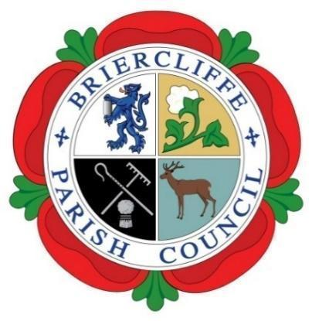
Briercliffe with Extwistle Parish Council
Thursday 2nd July 2026 at 7:00pm at Briercliffe Community Centre
Present: Councillors: Pippa Lishman (Chair), Maggie Lishman, Roger Frost
In Attendance: R Greenwood (Clerk)

The Chair, Cllr P Lishman, opened and welcomed all to the meeting.
 | Actions by Clerk | Cllr Support
26/27/082 Apologies for absence
Apologies were received, and accepted, from Cllrs Carrie Halstead, Nicola Harvey, Sammy Phillips and Gordon Lishman

26/27/083 Disclosable Pecuniary Interest
None received

26/27/084 To Approve the AGAR
The internal auditor, K M Solutions Ltd, has completed the Internal Audit for the financial year 25/26.

They were delayed completing this due to staff holidays.

The Chair signed the Annual Governance and Accountability Return 202/5/26 Forms

The Chair initialed the Explanation of Variances.

26/27/085 Dates of the Next Meetings
The dates of the parish council and strategy meeting 2026.

- 6th August 2026 at 7pm
- 13th August 2026 Strategy Meeting, Councillors only
- 3rd September 2026 at 7pm
- Either 10th or 17th September Meet and Greet Event
- 1st October 2026 at 7pm
- 12th November 2026 at 7pm
- 3rd December 2026 at 7pm

